Lab # 13

Exception Handling

OBJECTive:
To study exception-handling (try, catch, throw, throws, finally) and creating your own exception subclasses.

THEORY:

13.1 EXCEPTION
An exception is an abnormal condition that arises in a code sequence at run time. In other words, an exception is a run-time error. In computer languages that do not support exception handling, errors must be checked and handled manually—typically through the use of error codes, and so on. This approach is as cumbersome as it is troublesome. Java’s exception handling avoids these problems and, in the process, brings run-time error management into the object-oriented world.

Exception-Handling Fundamentals:
A Java exception is an object that describes an exceptional (that is, error) condition that has occurred in a piece of code. When an exceptional condition arises, an object representing that exception is created and thrown in the method that caused the error.
That method may choose to handle the exception itself, or pass it on. Either way, at some point, the exception is caught and processed. Exceptions can be generated by the Java run-time system, or they can be manually generated by your code.

Java exception handling is managed via five keywords: try, catch, throw, throws, and finally.

Using try and catch:
Although the default exception handler provided by the Java run-time system is useful for debugging, you will usually want to handle an exception yourself. Doing so provides two benefits. First, it allows you to fix the error. Second, it prevents the program from automatically terminating.

To guard against and handle a run-time error, simply enclose the code that you want to monitor inside a try block. Immediately following the try block, include a catch clause that specifies the exception type that you wish to catch.

class Exc2 {
public static void main(String args[]) {
int d, a;
try { // monitor a block of code.
d = 0;
a = 42 / d;
System.out.println("This will not be printed.");
} catch (ArithmeticException e) { // catch divide-by-zero error
System.out.println("Division by zero.");
}
System.out.println("After catch statement.");
}
}

Output:

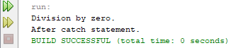

Using throw:

So far, you have only been catching exceptions that are thrown by the Java run-time system. However, it is possible for your program to throw an exception explicitly, using the throw statement. The general form of throw is shown here:

throw ThrowableInstance;

Here, ThrowableInstance must be an object of type Throw able or a subclass of
Throwable. Simple types, such as int or char, as well as non-Throwable classes, such as String and Object, cannot be used as exceptions. There are two ways you can obtain a Throwable object: using a parameter into a catch clause, or creating one with the new operator.

Here is a sample program that creates and throws an exception. The handler that catches the exception rethrows it to the outer handler.

// Demonstrate throw.
class ThrowDemo {
static void demoproc() {
try {
throw new NullPointerException("demo");
} catch(NullPointerException e) {
System.out.println("Caught inside demoproc.");
throw e; // rethrow the exception
}
}
public static void main(String args[]) {
try {
demoproc();
} catch(NullPointerException e) {
System.out.println("Recaught: " + e);
}
}
}

OUTPUT:

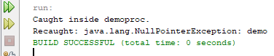

Throws:

If a method is capable of causing an exception that it does not handle, it must specify
this behavior so that callers of the method can guard themselves against that exception.
You do this by including a throws clause in the method’s declaration. A throws clause lists the types of exceptions that a method might throw. This is necessary for all exceptions, except those of type Error or RuntimeException, or any of their subclasses.
All other exceptions that a method can throw must be declared in the throws clause. If they are not, a compile-time error will result.
This is the general form of a method declaration that includes a throws clause:

type method-name(parameter-list) throws exception-list
{
// body of method
}

Example

class ThrowsDemo {
static void throwOne() throws IllegalAccessException {
System.out.println("Inside throwOne.");
throw new IllegalAccessException("demo");
}
public static void main(String args[]) {
try {
throwOne();
} catch (IllegalAccessException e) {
System.out.println("Caught " + e);
}
}
}

OUTPUT:

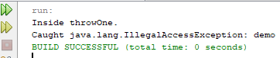

Finally:

finally creates a block of code that will be executed after a try/catch block has completed and before the code following the try/catch block. The finally block will
execute whether or not an exception is thrown. If an exception is thrown, the finally
block will execute even if no catch statement matches the exception.
The finally clause is optional. However, each try statement requires at least one catch or a finally clause.

Java’s Built-in Exceptions:
Inside the standard package java.lang, Java defines several exception classes. A few have been used by the preceding examples.
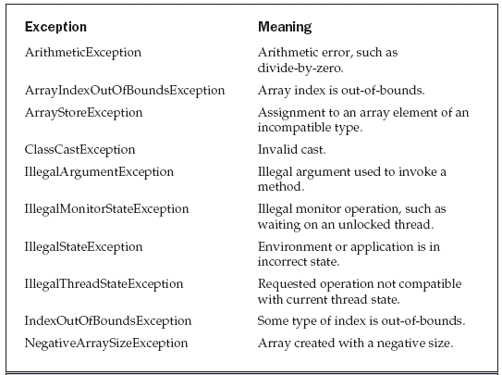

LAB TASK

Refining Your Calculator: Your primary task for this lab is to restructure your calculator to handle exceptions. You can put the method in a try catch clause.
- Write a program that accepts a test score, that is, a positive integer in the range 0 through 100 inclusive, and displays an equivalent letter grade: A (90), B (80–89), C (70–79), D (60–69), F (under 60). Throw an exception if the input is in the wrong format or if it is out of range, print an error message, and halt gracefully.

- Write a program that meet the following requirements:
■ Creates an array with 100 randomly chosen integers.
■ Prompts the user to enter the index of the array, then displays the corresponding element value. If the specified index is out of bounds, display the message Out of Bounds.

